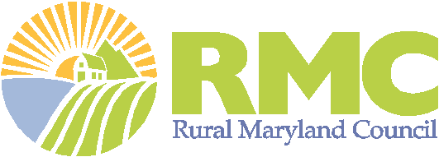

2021 Rural Summit Sponsorship Form

Please complete and return this form with your enclosed check.
Name for Receipt:
Please complete the following so that a receipt may be mailed to you:
Name:
Company or Organization:
Mailing Address:
City, State, Zip code:
Contact Person Phone:
Email: Sponsorship Level & Amount:
Name for Sponsor Acknowledgement*: ___________________________________________________________
(*Name provided will appear as written in the Rural Summit marketing materials, website, and other records)

Do you want exhibit space (one 6’ table & 2 chairs for sponsorship levels of $500 or more)? Yes ☐ No ☐

I understand by making this sponsorship, I am requested to:
- Provide company/organization’s logo for authorized use in summit publicity, printed materials, website, etc.;
- Accept exhibit space for sponsorship levels of $500 or more if marked yes above;
- Attend the event, with complimentary ticket(s) for donations of $250 or more as outlined in the sponsorship levels.
Please make checks payable and mail to: Rural Maryland Foundation
P.O. Box 1544
Annapolis, MD 21404

For more information on other sponsorship opportunities, including noncash gifts, please contact Charlotte Davis, Executive Director, Rural Maryland Council, at 410.841.5774 or charlotte.davis@maryland.gov.
Thank You for Your Support!

Rural Maryland Foundation is a 501 (c)(3) nonprofit organization, a public charity— donations are tax deductible to the fullest extent allowed by law. A copy of the Foundation’s current financial statement is available upon request by contacting the Rural Maryland Council at 410.841.5772. Documents and information submitted to the State of Maryland under the Maryland Charitable Solicitations Act are available from the Office of the Secretary of State for the cost of copying and postage.

